|  |  |
| --- | --- |
|  | 🞂**MANETIC RESONANCE IMAGING AND SCANNER**  (MRI SCANNER) |
|  |  |
|  | **GAURAV WANKAR** 🞂 |
|  |  |
|  | DEPARTMENT OF ELECTRONICS AND TELECOMMUNICATION, GOVINDRAO WANJARI COLLEGE OF ENGINEERING AND TECHNOLOGY, SALAI GODHANI,HUDKESHWAR ROAD NAGPUR 441 204-INDIA |
|  |  |
|  | ***Abstract*** |
|  |  |
|  | Magnetic Resonance Imaging is a spectroscopic Imaging technique used in medical settings to produce images of the inside of the human body. The Magnetic Resonance Imaging is accomplished through the absorption and the emission of the energy of the radio frequency.  MRI is perform a very important role in the medical sectors to identify the actual disease or the injury in the tissues, and shows the actual image.  Magnetic Resonance Imaging provides better soft tissue contrast than CT and can differentiate better between fat, water, muscle, and other soft tissue than CT (CT is usually better at imaging bones). These images provide information to physicians and can be useful in diagnosing a wide variety of diseases and conditions.  ‘In future, the technology of the MRI Scanners will be in the higher Requirement. In the Medical as well as in the commercial sectors.’ |
|  |  |
|  |  |
|  |  |
|  | ***Introduction*** |
|  |  |
|  | Magnetic resonance imaging (MRI) is a [medical imaging](https://en.wikipedia.org/wiki/Medical_imaging) technique used in [radiology](https://en.wikipedia.org/wiki/Radiology) to form pictures of the [anatomy](https://en.wikipedia.org/wiki/Anatomy) and the [physiological](https://en.wikipedia.org/wiki/Physiological) processes of the body. [MRI scanners](https://en.wikipedia.org/wiki/Physics_of_magnetic_resonance_imaging#MRI_scanner) use strong [magnetic fields](https://en.wikipedia.org/wiki/Magnetic_field), magnetic field gradients, and [radio waves](https://en.wikipedia.org/wiki/Radio_wave) to generate images of the organs in the body. MRI does not involve [X-rays](https://en.wikipedia.org/wiki/X-rays) or the use of [ionizing radiation](https://en.wikipedia.org/wiki/Ionizing_radiation), which distinguishes it from [CT](https://en.wikipedia.org/wiki/CT_scan) and [PET scans](https://en.wikipedia.org/wiki/PET_scan). MRI is a [medical application](https://en.wikipedia.org/wiki/Nuclear_magnetic_resonance#Medicine) of [nuclear magnetic resonance](https://en.wikipedia.org/wiki/Nuclear_magnetic_resonance) (NMR) which can also be used for imaging in other [NMR applications](https://en.wikipedia.org/wiki/Nuclear_magnetic_resonance#Applications), such as [NMR spectroscopy](https://en.wikipedia.org/wiki/Nuclear_magnetic_resonance_spectroscopy).  The magnetic Resonance Imaging is accomplished through the absorption and emission of energy of the  Radio frequency . Human Body is mainly composed of about 63% hydrogen. |
|  |  |
|  |  |
|  |  |
|  |  |
|  |  |
|  |  |
|  |  |
|  |  |
|  |  |
|  |  |
|  |  |
|  |  |
|  |  |
|  |  |
|  |  |
|  |  |
|  |  |
|  |  |

***Literature Review***

(MRI SCANNER)

MRI scanners use strong magnetic fields, magnetic field gradients, and radio waves to generate images of the organs in the body.   
  
In the 1930s, physicist I.I. Rabi developed a way to measure the magnetic properties (spin) and sodium movement. In his work, Rabi developed a form of MR imaging called nuclear magnetic resonance (NMR). That work became the basis of medical MRIs.

From the past research, the size of MRI is much bigger and the heavier and contain a lot of space and need the special observation, Hence there is the most need of the new models and the technology of the MRI Scanners . Hence, I selected the topic for the research and development in the MRI technology.

 Among the studies reviewed, a lack of uniformity in MRI equipment and techniques, conflicting sensitivity and specificity of imaging criteria for median nerve compression, and a paucity of normative data were noted. Based on this review, we conclude that MRI is not a useful tool for large-scale population screening, and is unhelpful as a routine preoperative study MRI is useful for confirmed CTS with persistent postoperative findings and in cases m which anatomic anomalies are suspected preoperative!)'. The use of MRI for guiding treatment in individuals with clinical signs and symptoms of CTS but with normal electro diagnostics studies remains undetermined.

The purpose of this study was to compare the MRI findings of the wrists of patients with carpal tunnel syndrome (CTS) and controls. We present a new MRI parameter, the pressure angle of the median nerve, in CTS patients.

***METHODLOGY AND EXPREMENTATION***

When the large magnetic field, hydrogen atoms have a strong tendency to align in the direction of the magnetic field.

Inside the bore of the Scanner, the magnetic field runs down the center of the tube in which the patient is line up in either the direction of the feet or the head.

The majority will cancel each other, but the net number of protons is sufficient to produce image.

***Energy Absorption***

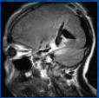The MRI machine applies radio frequency (RF) pulse that is specific to hydrogen.

The RF pulse are are applied through a coil that is specific to the part of the body being scanned.

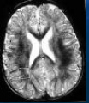

***Resonance***

The gradient magnets are rapidly turned magnetic field.

The pulse directed to a specific are of the body causes the protons to absorb energy and spin in different direction, which is known as resonance.

***Imaging***

When the RF pulse is turned off the hydrogen protons slowly return to their natural alignment within the magnetic fields and release their excess stored energy. This is known as relaxation.

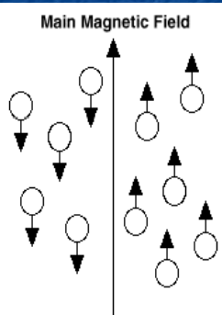

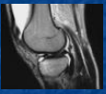

***Results and Discussion***

 The protons are affected by fields from other atoms to which they are bonded, it is possible to separate responses from hydrogen in specific compounds. To perform a study, the person is positioned within an [MRI scanner](https://en.wikipedia.org/wiki/Physics_of_magnetic_resonance_imaging#MRI_scanner) that forms a strong [magnetic field](https://en.wikipedia.org/wiki/Magnetic_field) around the area to be imaged. First, energy from an [oscillating](https://en.wikipedia.org/wiki/Oscillation) magnetic field is temporarily applied to the patient at the appropriate [resonance](https://en.wikipedia.org/wiki/Resonance) frequency. Scanning with X and Y gradient coils causes a selected region of the patient to experience the exact magnetic field required for the energy to be absorbed. The atoms are [excited](https://en.wikipedia.org/wiki/Excited_state) by a [radio frequency](https://en.wikipedia.org/wiki/Radio_frequency) (RF) pulse and the resultant signal is measured by a [receiving coil](https://en.wikipedia.org/wiki/Radiofrequency_coil). The RF signal may be processed to deduce position information by looking at the changes in RF level and phase caused by varying the local magnetic field using [gradient coils](https://en.wikipedia.org/wiki/Physics_of_magnetic_resonance_imaging#Gradients). As these coils are rapidly switched during the excitation and response to perform a moving line scan, they create the characteristic repetitive noise of an MRI scan as the windings move slightly due to [magnetostriction](https://en.wikipedia.org/wiki/Magnetostriction).

***Magnetism***

1. The top spinning in the earth’s gravity . The gravity tries to pull it down but it stays upright due to its fast rotation .
2. A charge spinning in the magnetic field.

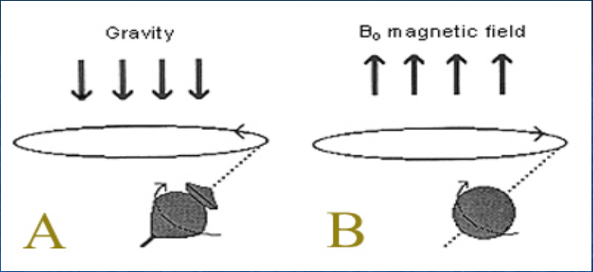

Fig: 2

1. The protons spinning in the nature, without an external strong field . The directions of spins are random and cancel out each other. The net magnetization is nearly 0.
2. In the presence of a large external magnetic field Bo the spins align themselves either against (high energy state) or along (low energy state). There is a slight abundance of spins aligned in the low energy state.

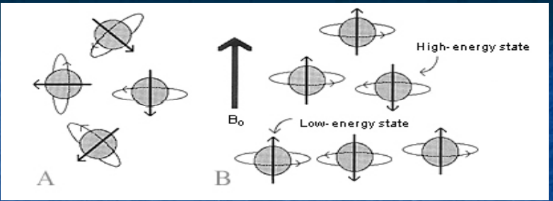

Fig: 3

1. The Compass needle (a small magnet ) aligns itself with a

N/s-s/N direction when placed in a large magnetic field.

1. When another strong magnet is bought near the aligned compass needle the magnetic fields of all three magnets ( the compass needle) realigns itself away from itself original orientation.
2. When the perturbing magnetic field is removed suddenly the compass needle magnet realigns itself with the large external magnet field, but before realigning, it wobbles around the point of stability and gradually comes to rest.

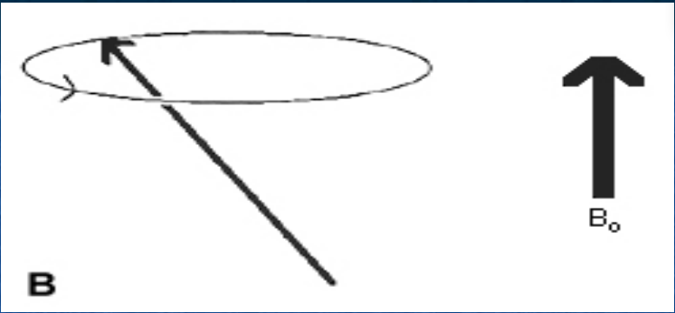

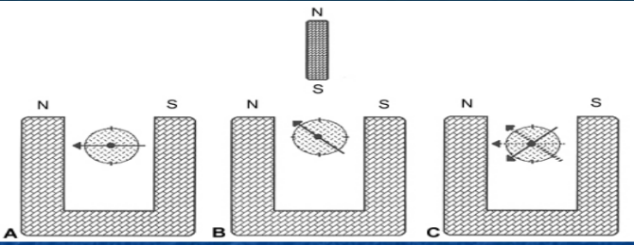

Fig: 4

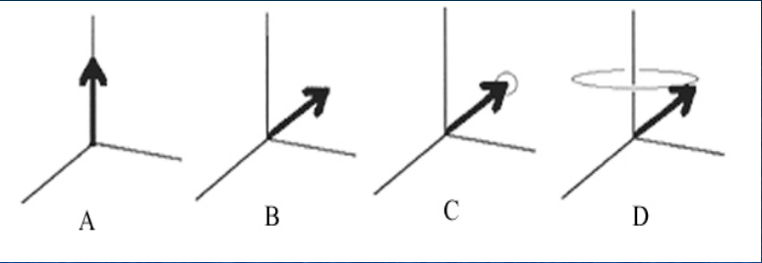

The spin of the proton is represented by a vector B eith a direction and magnitude . Its relation to the direction of the external magnetic field Bo is represented by an angle.

1. The spin of a proton aligned to Bo in the Z-axis.
2. 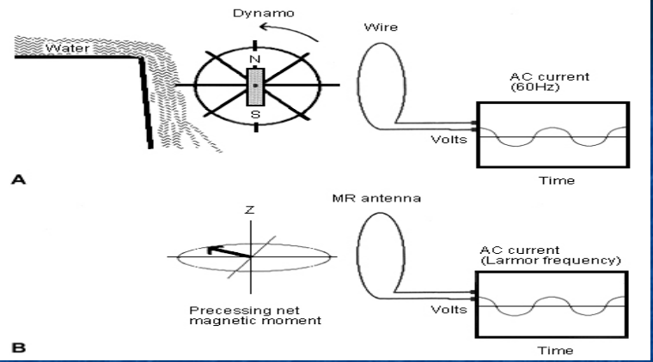An external perturbing magnetic field, B1 is applied with the knocks the vector out of its axis, which now is aligned at a new angle with respect to Bo.
3. As the perturbing field B1 is removed the vector gradually starts returning back to its original state.
4. Begins to wobble.

***Resonance***

The gradient coils.

1. 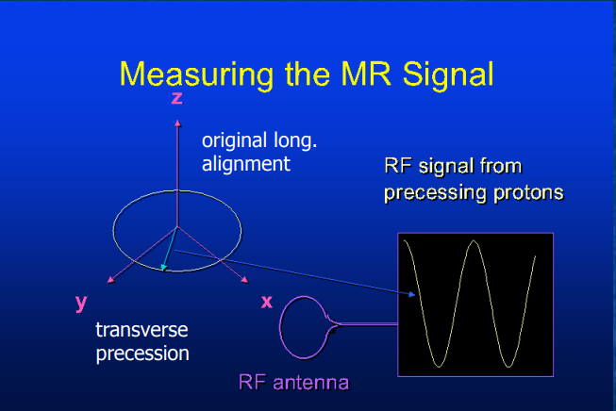The body placed in the core of the the magnet with B0 aligned to its long axis.
2. The gradient coil oriented in the Z-axis (along the long axis of the body) which gradually and linearly increases from left to right.
3. At the center of the gradient field, the frequency is equal to that of B0, but at a distance, ∆X the field changes by a factor of ∆B0**.**

The resonance equation shows that the resonance frequency v of a spin is proportional to the magnetic field, B0, it is experiencing.



 Where is the gyromagnetic ratio. [ the ratio of the magnetic moment of a spinning charged particle to its angular momentum].

***Conclusion***

A study conducted indicates that India currently has approximately 3500 MRI machines which includes low field, 1.5T, 3 T and refurbished machines and installing 350-400 machines per year.  
Every year, approximately 10 million patients undergo MRI procedures.

Introducing highest quality MRI services into your practice can generate new revenues. Until now these MR systems have been too costly, difficult to install, and hard to operate for many.

Introducing highest quality MRI services into your practice can generate new revenues. Until now these MR systems have been too costly, difficult to install, and hard to operate for many.

Where is your scanner in the 12.8 year lifecycle ? If it's newer, you may consider upgrading your system to the latest technology and advanced software to improve workflow and productivity. If it's older, it may be time to investigate new systems.

The prevalence rates of the spectrum of neurological disorders from different regions of the country ranged from 967-4,070 with a mean of 2394 per 100,000 population, providing a rough estimate of over 30 million people with neurological disorders (excluding neuroinfections and traumatic injuries).

India has the large number of population, and having a lot of healty problem faced every year, The MRI technology boost the identification of the the internal diseases of the brain and spinal cord, bones and joints, breasts, heart and blood vessels.

A report by the Indian Council of Medical Research (ICMR) said that cardiovascular ailments account for nearly 17 percent of all deaths in the South Asian country. On average, around 10 million people die in India every year.

The number of deaths due to heart attacks in India has remained consistently over 25,000 in the last four years, and over 28,000 in the last three year.

The MRI scanners is the way to relief the people. And identify the internal organ diseases before the time and take precaution before it affects the body.



***References:***

